Library Management System

(MYSQL PROJECT)

Create a database named library and following TABLES in the database:

1. Branch
2. Employee
3. Books
4. Customer
5. IssueStatus
6. ReturnStatus

. Branch .
- Branch_no - Set as PRIMARY KEY
- Manager_Id
- Branch_address
- Contact_no
create database Library;
use Library;
create table Branch( Branch_no int auto_increment primary key,
Manage_ID int,Address varchar
(200), Contact_no int);

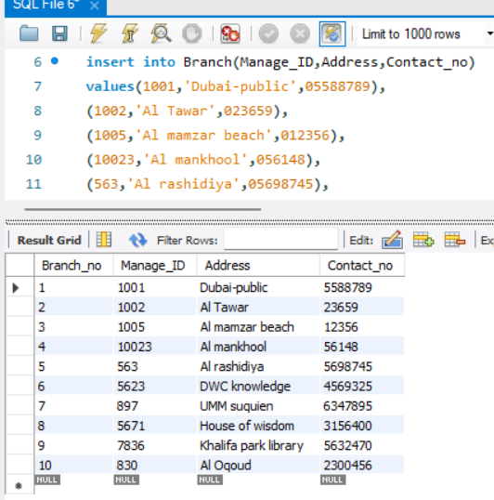

Employee.
- Emp_Id – Set as PRIMARY KEY
- Emp_name
- Position
- Salary
- Branch_no - Set as FOREIGN KEY and it refer Branch_no in Branch table
create table Employe(
Emp_Id int auto_increment primary key,
Emp_name varchar(50),
Position_area varchar(50),
Salary decimal(10,3),
Branch_no int,foreign key (Branch_no) references Branch(Branch_no));

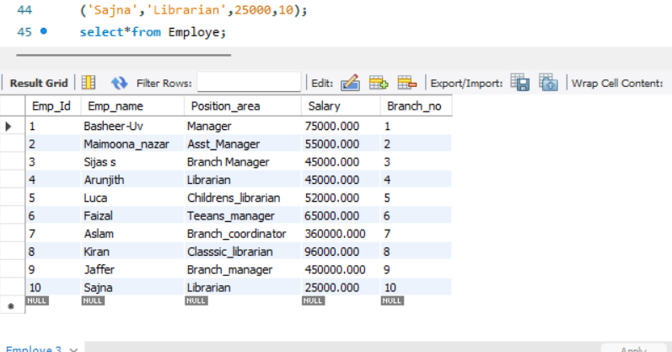

Books
- ISBN - Set as PRIMARY KEY
- Book_title
- Category
- Rental_Price
- Status [Give yes if book available and no if book not available]
- Author
- Publisher
create table Books(
ISBN int primary key,
Book_title varchar(250) not null,
Category varchar(50),
Rental_Price decimal(10,2),
Status enum('yes','no') default 'yes',
Author varchar(100),
Publisher varchar (255) );
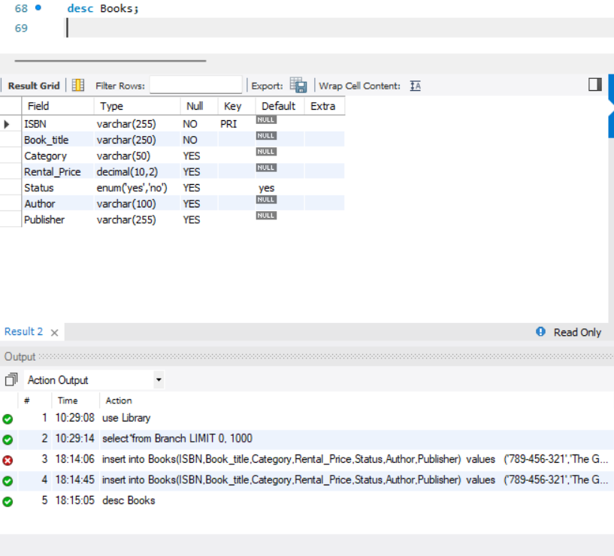

Customer
- Customer_Id - Set as PRIMARY KEY
- Customer_name
- Customer_address
- Reg_date
create table Customer (Customer_id int primary key ,
Customer_Name varchar (250),
Customer_Add varchar (100), Reg_Date date);
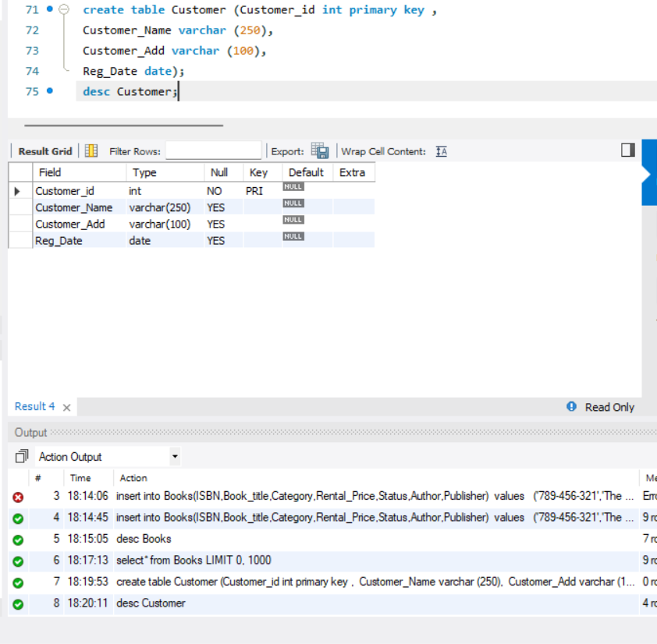

IssueStatus
- Issue_Id - Set as PRIMARY KEY
- Issued_cust – Set as FOREIGN KEY and it refer customer_id in CUSTOMER table Issued_book_name
- Issue_date
- Isbn_book – Set as FOREIGN KEY and it should refer isbn in BOOKS table
create table IssueStatus(Issue_Id INT PRIMARY KEY, Issued_custid int, Issued_book_name VARCHAR(255), Issue_date DATE, Isbn_book varchar (250), FOREIGN KEY (Issued_custid) references Customer (Customer_id), FOREIGN KEY (Isbn_book) REFERENCES Books(ISBN));
desc IssueStatus;

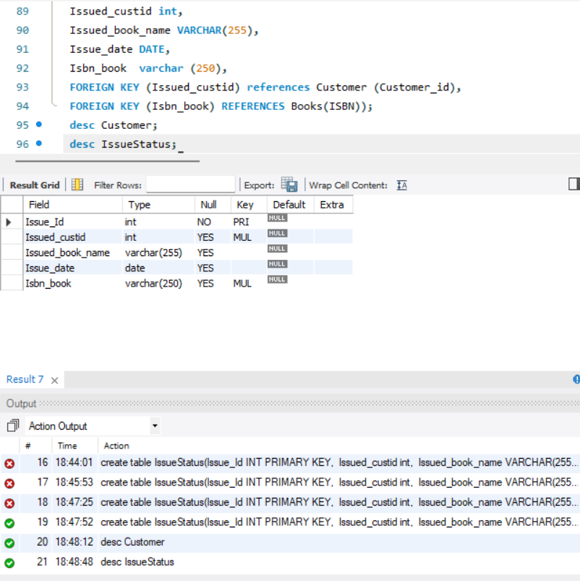

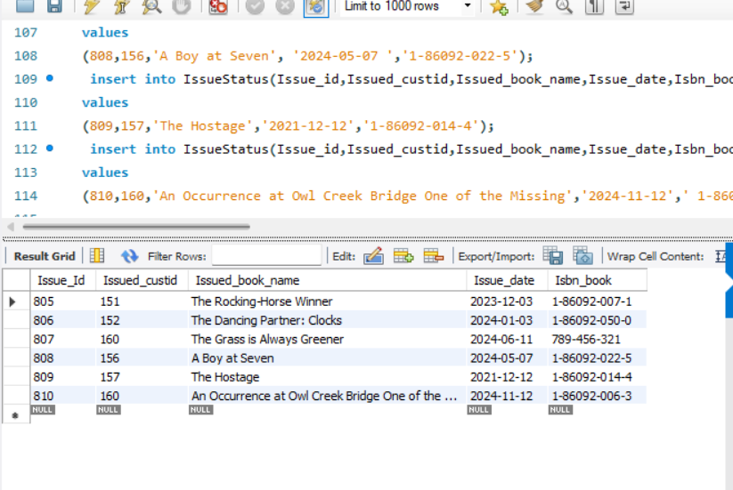

ReturnStatus
- Return_Id - Set as PRIMARY KEY
- Return_cust
- Return_book_name
- Return_date
- Isbn_book2 - Set as FOREIGN KEY and it should refer isbn in BOOKS table

create table Return_status(Return_Id INT PRIMARY KEY, Return_cust INT, Return_book_name VARCHAR(255), Return_date DATE, Isbn_book2 varchar (250), FOREIGN KEY (Return_cust) REFERENCES Customer(Customer_id), FOREIGN KEY (Isbn_book2) REFERENCES Books(ISBN));
desc Return_status;

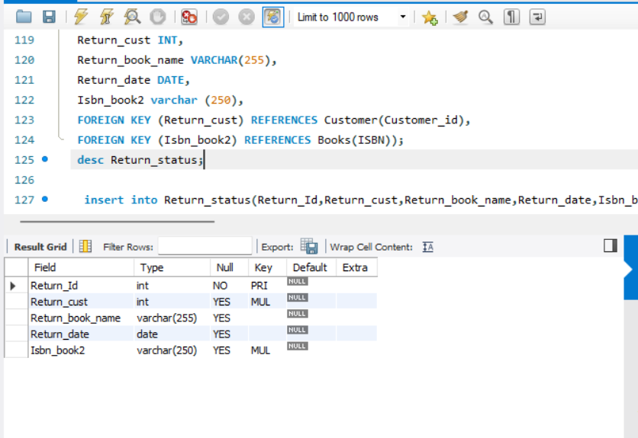

Display all the tables and Write the queries for the following :

1. Retrieve the book title, category, and rental price of all available books.

SELECT Book_title, Category, Rental_Price
FROM Books
WHERE Status = 'yes';

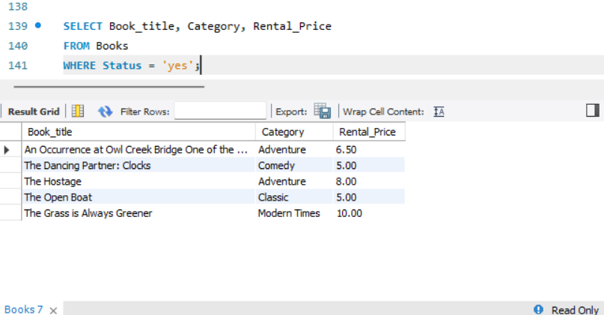

2. List the employee names and their respective salaries in descending order of salary.

SELECT Emp_name, Salary
FROM Employe
ORDER BY Salary DESC;

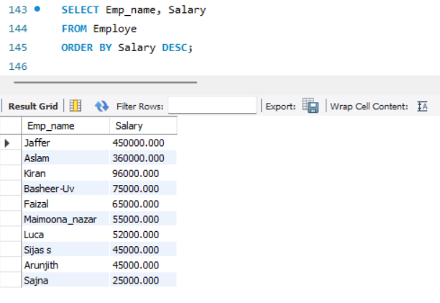

3. Retrieve the book titles and the corresponding customers who have issued those books.

SELECT Books.Book_title, Customer.Customer_Name
FROM Books
JOIN IssueStatus ON Books.ISBN = IssueStatus.Isbn_book
JOIN Customer ON IssueStatus.Issued_custid = Customer.Customer_Id;
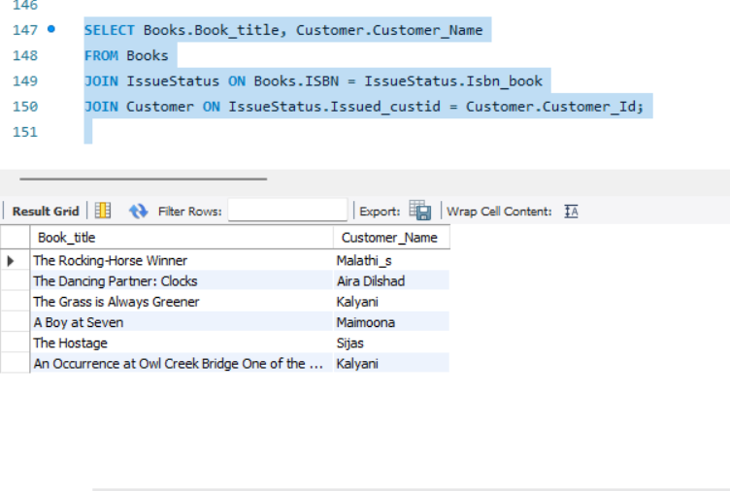

4. Display the total count of books in each category.

SELECT Category, COUNT(*) AS Total_Books
FROM Books
GROUP BY Category;

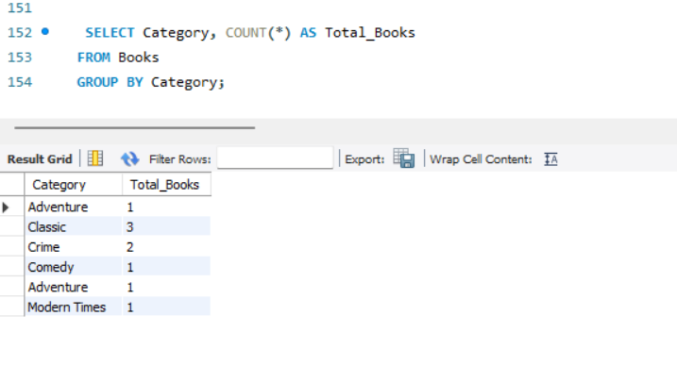
5. Retrieve the employee names and their positions for the employees whose salaries are above Rs.50,000.

SELECT Emp_name, Position_area
FROM Employe
WHERE Salary > 50000;
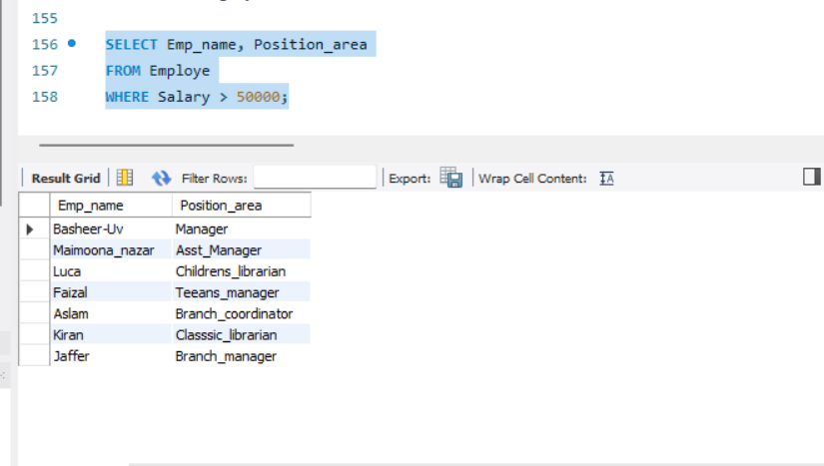

6. List the customer names who registered before 2022-01-01 and have not issued any books yet.

SELECT Customer_Name
FROM Customer
WHERE Reg_date < '2022-01-01'
AND Customer_id NOT IN (SELECT Issued_custid FROM IssueStatus);

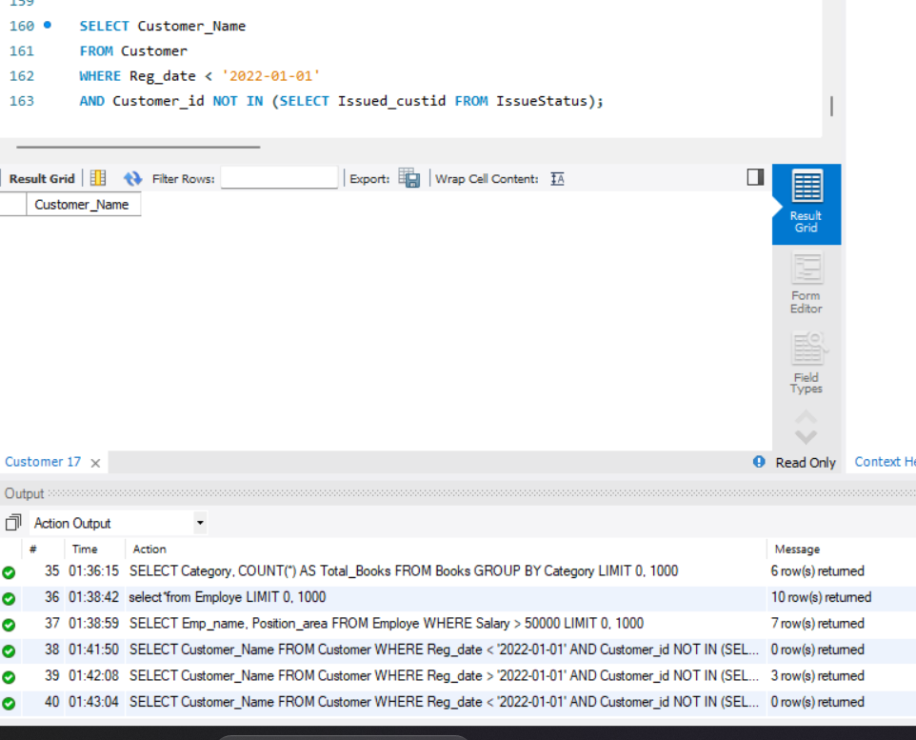

7. Display the branch numbers and the total count of employees in each branch.

SELECT Branch_no, COUNT(*) AS Total_Employs
FROM Employe
GROUP BY Branch_no;

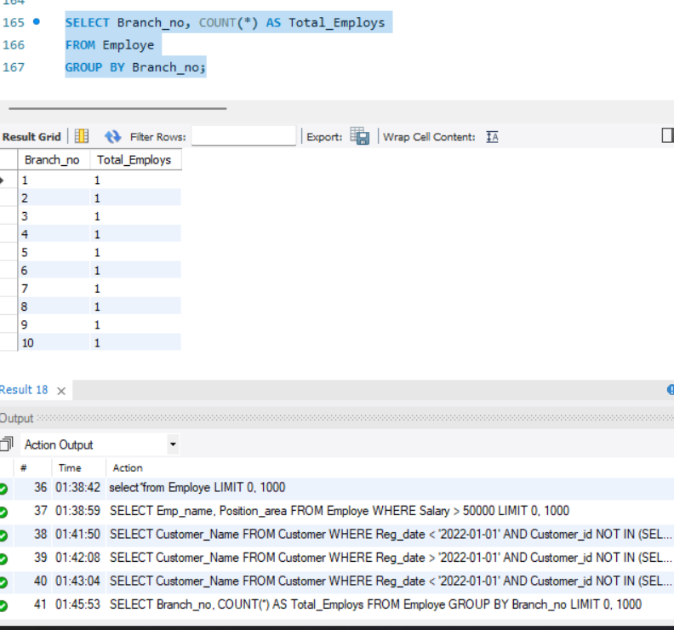

8. Display the names of customers who have issued books in the month of June 2024.

SELECT Customer.Customer_Name
FROM Customer
JOIN IssueStatus ON Customer.Customer_id = IssueStatus.Issued_custid
WHERE Issue_date BETWEEN '2024-06-01' AND '2024-06-30';

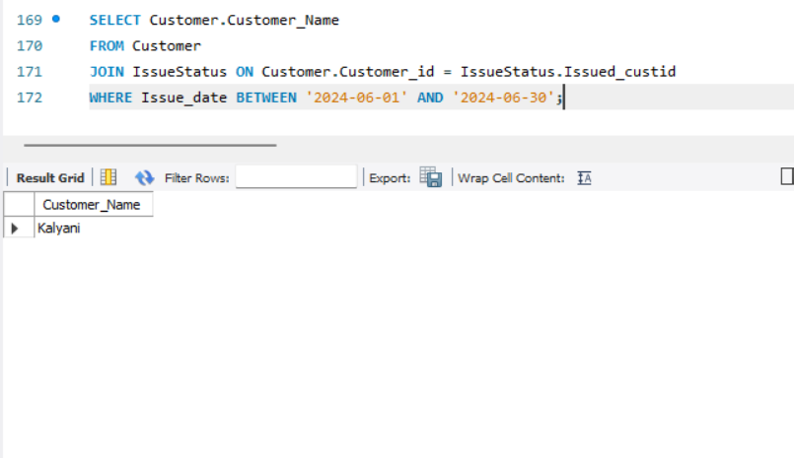
9. Retrieve book_title from book table containing history.

SELECT Book_title
FROM Books
WHERE Book_title LIKE '%history%';

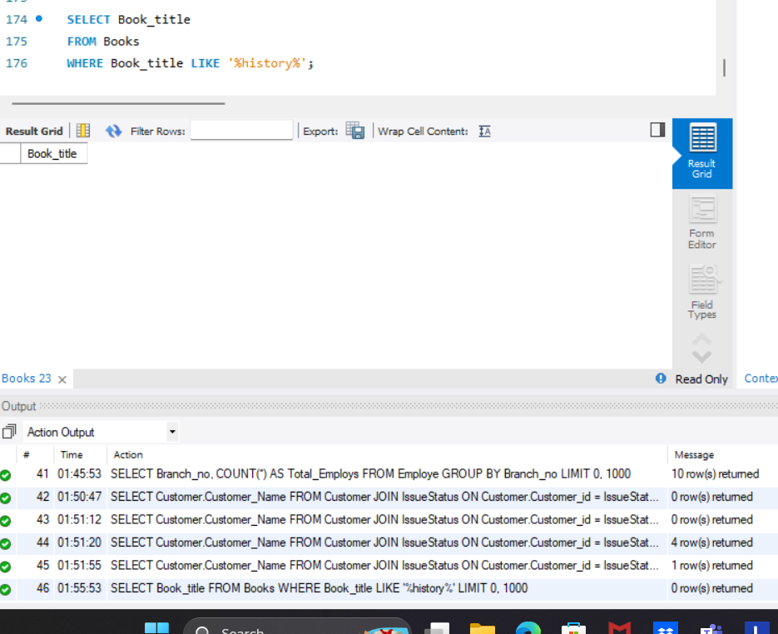

10.Retrieve the branch numbers along with the count of employees for branches having more than 5 employees.

SELECT Branch_no, COUNT(*) AS Total_Employees
FROM Employe
GROUP BY Branch_no
HAVING COUNT(*) > 5;

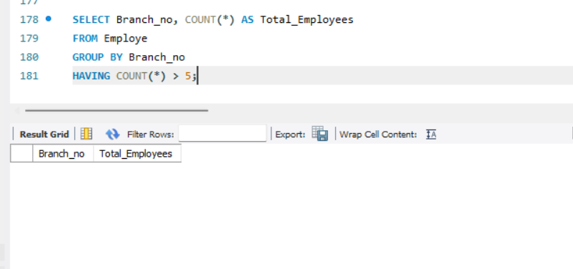
11. Retrieve the names of employees who manage branches and their respective branch addresses.

SELECT e.Emp_name, b.Address
FROM Employe e
JOIN Branchs b ON e.Emp_Id = b.Manage_ID;

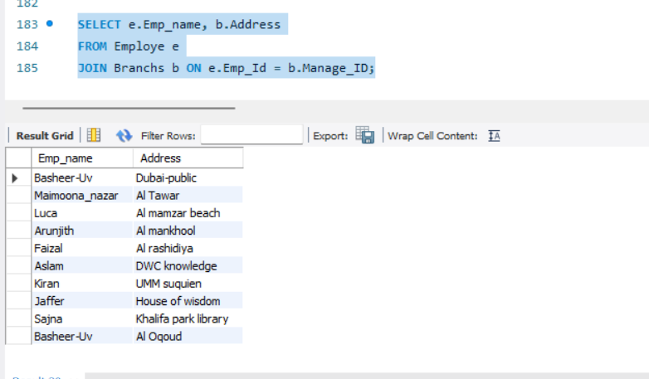

12. Display the names of customers who have issued books with a rental price higher than Rs. 6.5.

SELECT DISTINCT Customer.Customer_Name
FROM Customer
JOIN IssueStatus ON Customer.Customer_Id = IssueStatus.Issued_custid
JOIN Books ON IssueStatus.Isbn_book = Books.ISBN
WHERE Books.Rental_Price > 6.5;

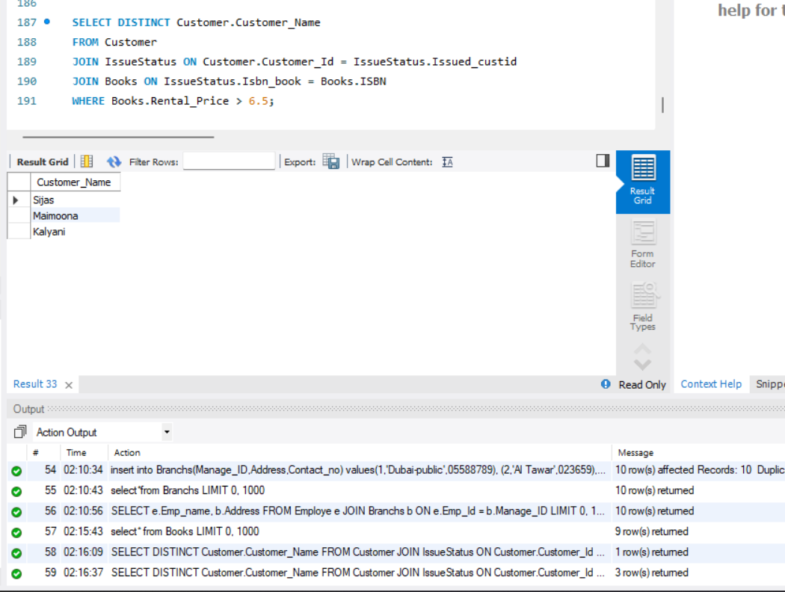

end##

